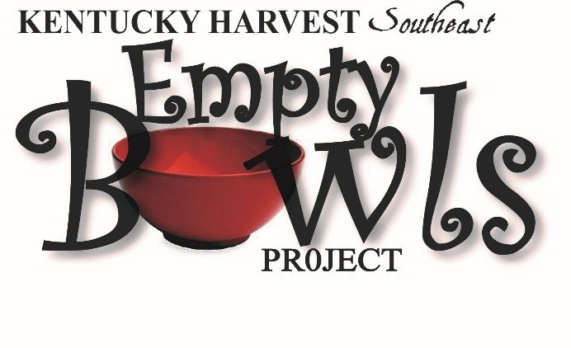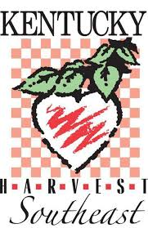

Kentucky Harvest Southeast/ Empty Bowl Project
305 W 5th St.
Corbin, Kentucky 40701

KY Harvest Southeast is a non-profit organization started in 2008. Our mission statement says, “We provide nutritional food to children and families by locating, organizing, and networking with those who can provide food to those who need food in a timely manner.”

Kentucky Harvest Southeast provides 100% of the funding for Kentucky Harvest Southeast Backpack Program for Flat Lick, Dewitt, and Barbourville City Schools in Knox Co. We are also involved in providing food and support to local pantries at Christian Life Fellowship in Barbourville, KCEOC Women’s /Families Shelter in Gray, Emergency Christian Ministries Williamsburg Ky, and the Everlasting Arms shelter in Corbin.

Through your tax deductible donation, we can keep these programs funded and growing to help provide more Knox Co children and families with nutritional food. It costs $362.50 each week for backpacks that have 7 meals for the weekend. We also have corporate sponsors who contribute $3,000 plus which helps us meet our $20,000 annual outlay for this program. All donations of any size are helpful and needed.

Will you please help us help the children and families of Knox Co in need?
100 % of your donation goes toward these programs with volunteers providing the services needed to run these programs. Below is a form to donate to our Empty Bowl Project.

Thanks for your time,

David Barton
President, Kentucky Harvest Southeast www.kentuckyharvestsoutheast.org
kyharvest.southeast@gmail.com 501 C3 Organization
606 627 6738

Kentucky Harvest Southeast Board David Barton President 606 627 6738
Gina Sears VP 606 524 2546 Rosemary Revoir Secretary 606 521 2316
Jim Revoir Treasurer 606 344 6673 Joann Maybrier 606 627 3171
Brendia Moses 606 627 0771 Jodi Carroll 606 524 7092
Teresa Pope 606 622 1797

Sponsorship Levels:
BRONZE $100 -$199 GOLD $300 - $499
SILVER $200 -$299 PLATINUM $500 OR MORE
NAME_________________________________
AMOUNT ______________________________________
Mail Donation To:
KENTUCKY HARVEST SOUTHEAST
305 W. 5th St.
Corbin, Ky. 40701

